**Redshift Exercise: Create an IAM User**

**Create an IAM User for Redshift**

In this exercise, you'll create an IAM user that you will use to access your Redshift cluster.

1. Navigate to the [IAM Dashboard](https://console.aws.amazon.com/iam/home#/home), and create an IAM user.

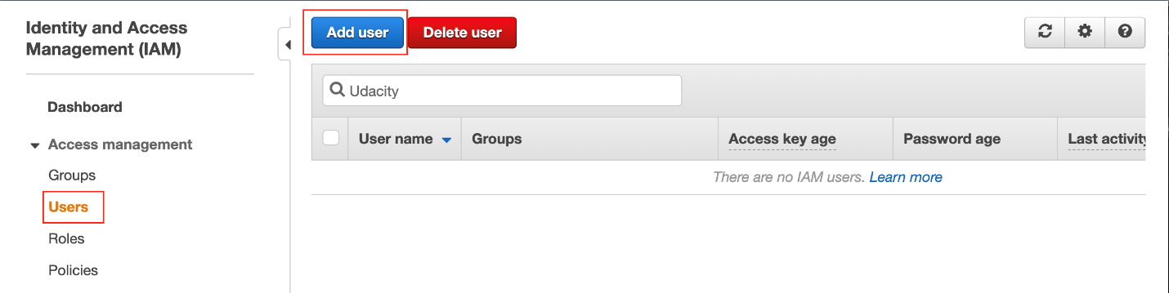

Add a new IAM user

1. Set the user name, and click **Next**. **DO NOT** check **Provide user access to the AWS Management Console - *optional***.

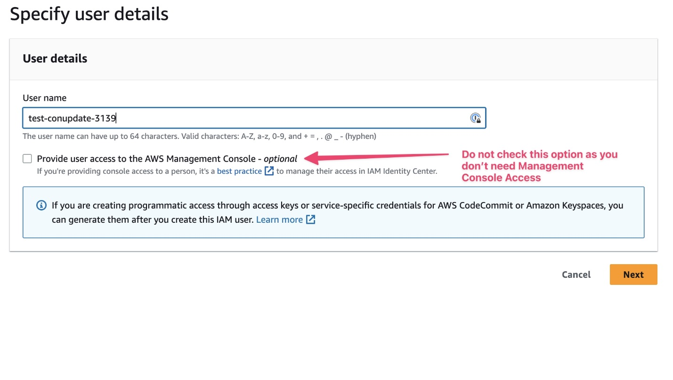

Set User name.

1. **Set permissions**  
   Choose **Attach existing policies directly** option.
   * Search for redshift and select **AmazonRedshiftFullAccess**.
   * Then, search for S3 and select **AmazonS3ReadOnlyAccess**.

After selecting both policies, choose **Next: Tags**. Skip this page and choose **Next: Review**.

Create IAM user → Set permissions → Select *AmazonRedshiftFullAccess*

Create IAM user → Set permissions → Select *AmazonS3ReadOnlyAccess*

1. Provide tags [optional], review the details of the new user, and finally create the new user.
2. After a user is created successfully, click on the User name.

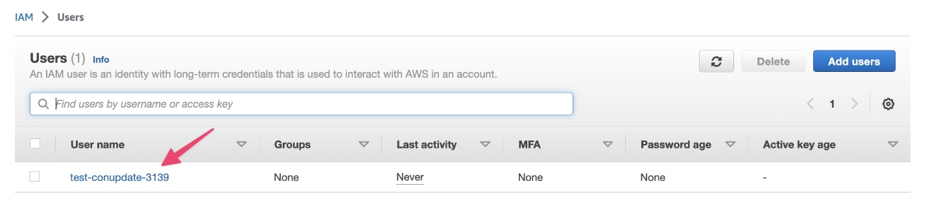

Select the created user.

1. Ignore **AWS Management Console** related warnings. Since you only need programmatic acces, this can be ignored. Go to **Security Credentials** and select **Create access key**.

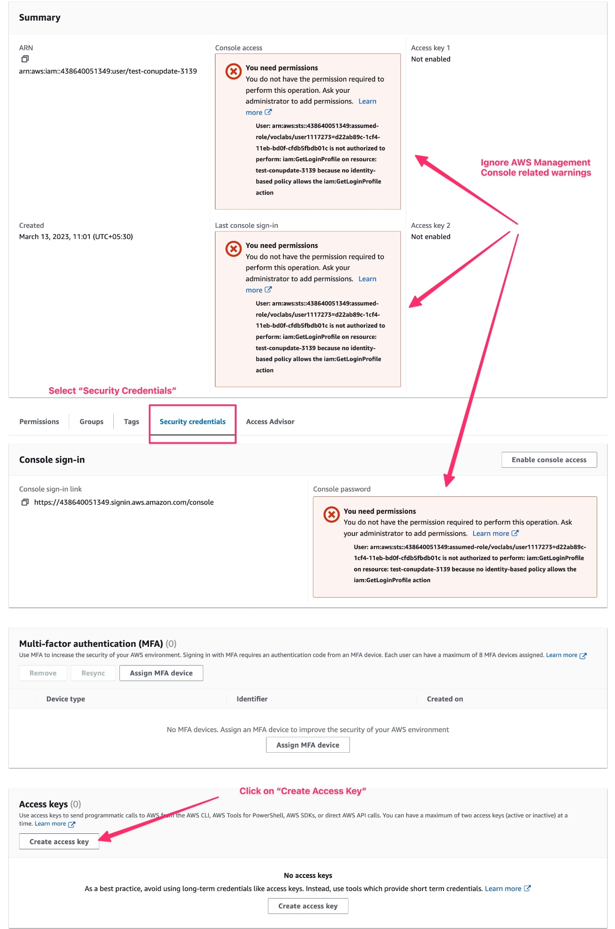

Create Access Key for the user.

1. Select **Command Line Interface (CLI)** and click **Next**.

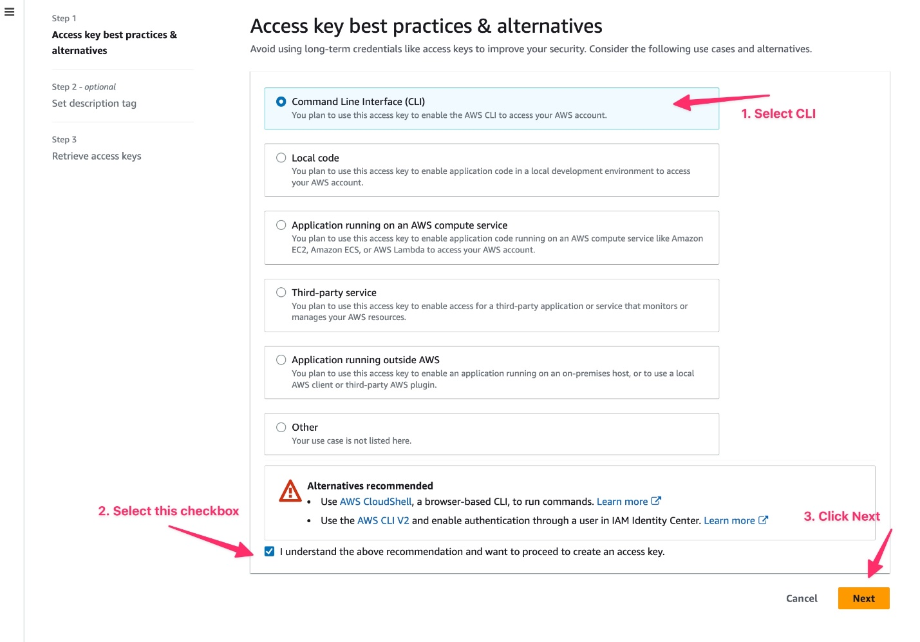

Select *Command Line Interface (CLI)*

1. Set description tag and click **Create access key**.

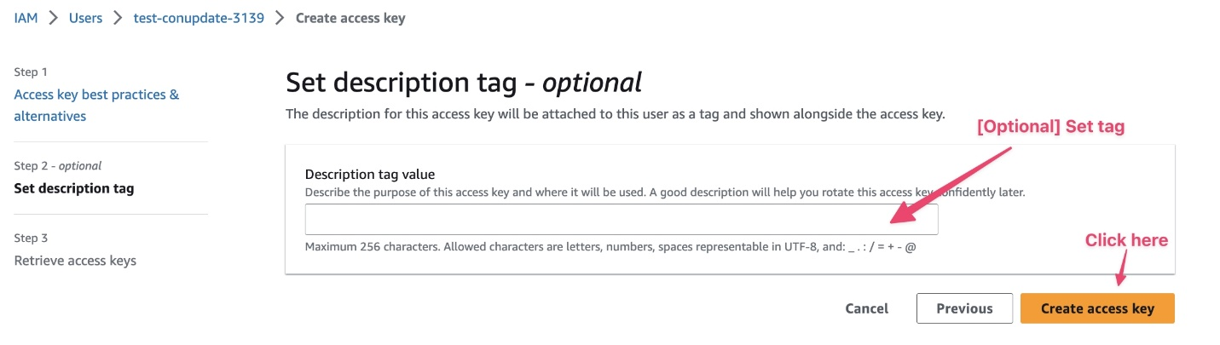

Optional - Set description tag for the access keys

1. Copy the created **Access key**, **Secret access key** and store it for later use. You can also download these as a *.csv* file.

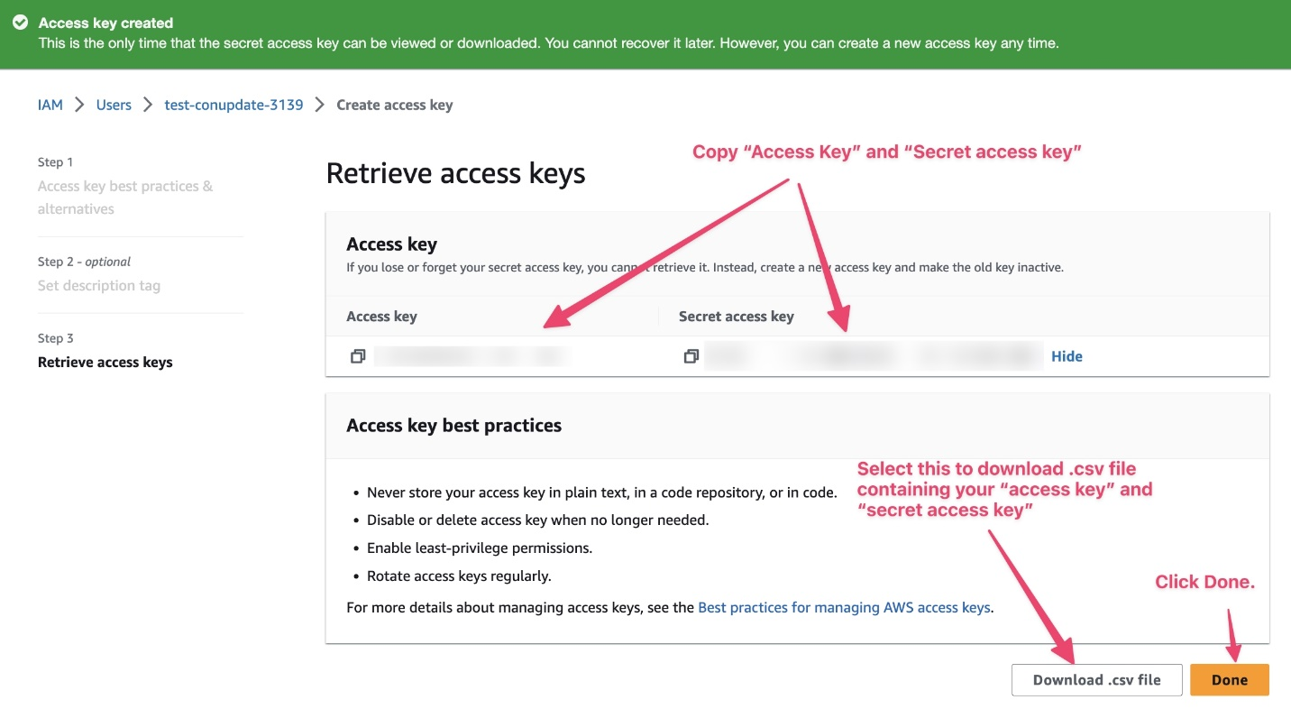

Copy *Access Key* and *Secret Access Key*

**Note** that you can generate a temporary Access key in the classroom as well, as shown in the snapshot below. But, the classroom generated access key is **valid for a for a few hours only**. Notice that it has a session token associated with it.

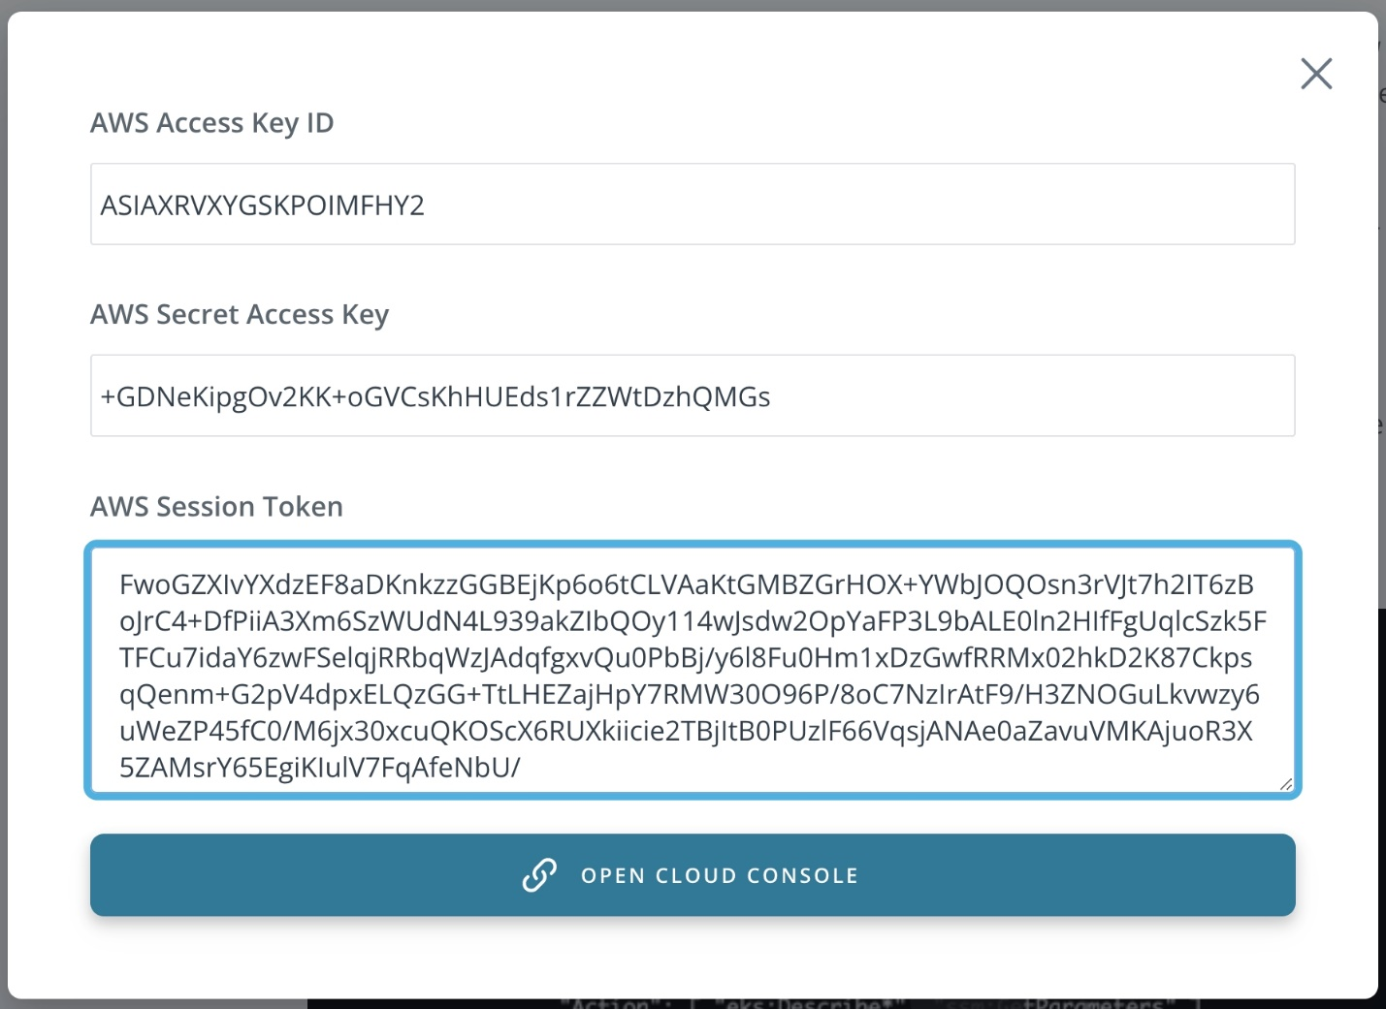

Access key shown in the classroom after clicking on the "OPEN CLOUD GATEWAY" button